Documenting RedBox FrontEnd Pipelines

Schedules

* Backup FTP
  + Backup of FTP Daily
* Process Yesterday Redbox Kiosk Data

Jobs

Schedule 1

1. Backup of FTP Daily

Input: Backup of Files

Output: FTP Backup Daily: Append to Dataset

Job Type: Import from External Data Source

Schedule 2

1. Process Session Dims

First:

Import Yesterday

Input: Yesterday Compressed XML

Output: Yesterday XML Compressed

Job type: Import from External Data Source

Time Period: prev 2 days

Job 1

Input: Yesterday XML Compressed

Output: Yesterday Session Elements

Job type : Flatten XML

Schema File Config: <!--Sample XML file generated by XMLSpy v2015 rel. 3 (x64) (http://www.altova.com)-->

<session xmlns:xsi="http://www.w3.org/2001/XMLSchema-instance" xsi:noNamespaceSchemaLocation="KioskAnalyticsSchemaSessionVariables.xsd">

<sessionId>String</sessionId>

<sessionType>String</sessionType>

<sessionStart>String</sessionStart>

<kioskID>String</kioskID>

<culture>String</culture>

<market>String</market>

<banner>String</banner>

<hasCheckout>String</hasCheckout>

<vendingMovie type="String" programName="String"/>

<recommendationsFlow>String</recommendationsFlow>

<recommendedTitles>String</recommendedTitles>

<recommendedTitlesShown>String</recommendedTitlesShown>

<abandon>String</abandon>

<sessionEnd>String</sessionEnd>

<sessionDuration>String</sessionDuration>

<Test>

<TestArray>text</TestArray>

<TestArray>text</TestArray>

</Test>

</session>

Available Dimensions: Test

Job 2

Input: Yesterday Session Elements

Output: Yesterday Session Formatted Filtered

Job Type: Custom SQL Query

Custom SQL Query

SELECT

`Yesterday Session Elements.sessionId` ,

`Yesterday Session Elements.sessionType` ,

`Yesterday Session Elements.sessionStart` ,

substr(regexp_replace(concat(substr(`Yesterday Session Elements.sessionStart` , 1, 19), ".", substr(`Yesterday Session Elements.sessionStart` , 21, 2), "0"), "/", "-"),1,23) as SessionStartFormatted,

`Yesterday Session Elements.kioskID`,

`Yesterday Session Elements.culture`,

`Yesterday Session Elements.market`,

`Yesterday Session Elements.banner`,

`Yesterday Session Elements.hasCheckout`,

`Yesterday Session Elements.vendingMovie_type`,

`Yesterday Session Elements.vendingMovie_programName`,

`Yesterday Session Elements.recommendationsFlow`,

`Yesterday Session Elements.recommendedTitles`,

`Yesterday Session Elements.recommendedTitlesShown`,

`Yesterday Session Elements.abandon`,

`Yesterday Session Elements.sessionEnd`,

`Yesterday Session Elements.sessionDuration`

FROM `Yesterday Session Elements`

1. Process View Events

Job 1

Input: Yesterday XML Compressed

Output: Yesterday View Events

XML Schema

<?xml version="1.0" encoding="UTF-8"?>

<!--Sample XML file generated by XMLSpy v2015 rel. 3 (x64) (http://www.altova.com)-->

<session>

<kioskID>String</kioskID>

<sessionId>String</sessionId>

<views>

<view viewName="String" viewSequence="String" viewVersion="String" viewCulture="String" viewStart="String" viewEnd="String" viewDuration="String" activeFlag="String">

<viewEvents>

<viewEvent subItemType="String" subItemValue="String"/>

<viewEvent subItemType="String" subItemValue="String"/>

</viewEvents>

</view>

<view viewName="String" viewSequence="String" viewVersion="String" viewCulture="String" viewStart="String" viewEnd="String" viewDuration="String" activeFlag="String">

<viewEvents>

<viewEvent subItemType="String" subItemValue="String"/>

<viewEvent subItemType="String" subItemValue="String"/>

</viewEvents>

</view>

</views>

</session>

Available Dimensions: view

Job type: Flatten XML

Job 2

Input: Yesterday View Events

Output: Yesterday View Events Formatted Filtered

Job Type: Custom SQL Query

Custom SQL Query

SELECT

`Yesterday View Events.kioskID`,

`Yesterday View Events.sessionId` ,

`Yesterday View Events.views_view_viewName` ,

`Yesterday View Events.views_view_viewSequence` ,

`Yesterday View Events.views_view_viewVersion` ,

`Yesterday View Events.views_view_viewCulture` ,

`Yesterday View Events.views_view_viewStart` ,

substr(regexp_replace(concat(substr(`Yesterday View Events.views_view_viewStart` , 1, 19), ".", substr(`Yesterday View Events.views_view_viewStart` , 21, 2), "0"), "/", "-"),1,23) as Views_View_ViewStartFormatted, `Yesterday View Events.views_view_viewEnd` ,

`Yesterday View Events.views_view_viewDuration` ,

`Yesterday View Events.views_view_activeFlag` ,

`Yesterday View Events.views_view_viewEvents_viewEvent_subItemType` ,

`Yesterday View Events.views_view_viewEvents_viewEvent_subItemValue`

FROM `Yesterday View Events`

1. Process Shopping Cart

Job 1

Input: Yesterday XML Compressed

Output: Yesterday ShoppingCart Elements

XML Schema

<?xml version="1.0" encoding="UTF-8"?>

<!--Sample XML file generated by XMLSpy v2015 rel. 3 (x64) (http://www.altova.com)-->

<session xmlns:xsi="http://www.w3.org/2001/XMLSchema-instance" xsi:noNamespaceSchemaLocation="KioskAnalyticsSchemaShoppingCart.xsd">

<kioskID>String</kioskID>

<sessionId>String</sessionId>

<sessionStart>String</sessionStart>

<shoppingCart>

<cartItems>

<cartItem add_sequence="String" removed="String" productFamily="String" action="String" price="String" quantity="String" productID="String" productType="String" status="String" sourceType="String"/>

<cartItem add_sequence="String" removed="String" productFamily="String" action="String" price="String" quantity="String" productID="String" productType="String" status="String" sourceType="String"/>

</cartItems>

<grandTotal>String</grandTotal>

</shoppingCart>

</session>

Available dimensions: shoppingCart/cartItems

Job 2

Input: Yesterday ShoppingCart Elements

Output: Yesterday ShoppingCart Formatted

Job Type: Custom SQL Query

Query:

SELECT

`Yesterday ShoppingCart Elements.kioskID`,

`Yesterday ShoppingCart Elements.sessionId` ,

`Yesterday ShoppingCart Elements.sessionStart` ,

substr(regexp_replace(concat(substr(`Yesterday ShoppingCart Elements.sessionStart` , 1, 19), ".", substr(`Yesterday ShoppingCart Elements.sessionStart` , 21, 2), "0"), "/", "-"),1,23) as SessionStartFormatted,

`Yesterday ShoppingCart Elements.shoppingCart_cartItems_cartItem_add_sequence` ,

`Yesterday ShoppingCart Elements.shoppingCart_cartItems_cartItem_removed` ,

`Yesterday ShoppingCart Elements.shoppingCart_cartItems_cartItem_productFamily`,

`Yesterday ShoppingCart Elements.shoppingCart_cartItems_cartItem_action`,

`Yesterday ShoppingCart Elements.shoppingCart_cartItems_cartItem_price`,

`Yesterday ShoppingCart Elements.shoppingCart_cartItems_cartItem_quantity` ,

`Yesterday ShoppingCart Elements.shoppingCart_cartItems_cartItem_productID` ,

`Yesterday ShoppingCart Elements.shoppingCart_cartItems_cartItem_productType`,

`Yesterday ShoppingCart Elements.shoppingCart_cartItems_cartItem_status` ,

`Yesterday ShoppingCart Elements.shoppingCart_cartItems_cartItem_sourceType`,

`Yesterday ShoppingCart Elements.shoppingCart_grandTotal`

FROM `Yesterday ShoppingCart Elements`

WHERE `Yesterday ShoppingCart Elements.shoppingCart_cartItems_cartItem_add_sequence` IS NOT NULL OR `Yesterday ShoppingCart Elements.shoppingCart_cartItems_cartItem_removed` IS NOT NULL

1. Process Promo Codes

Job 1

Input: Yesterday XML Compressed

Output: Yesterday PromoCodes

Job Type: Flatten XML

XML Schema

<?xml version="1.0" encoding="UTF-8"?>

<!--Sample XML file generated by XMLSpy v2015 rel. 3 (x64) (http://www.altova.com)-->

<session xmlns:xsi="http://www.w3.org/2001/XMLSchema-instance" xsi:noNamespaceSchemaLocation="KioskAnalyticsSchemaPromoCodesArray.xsd">

<kioskID>String</kioskID>

<sessionId>String</sessionId>

<sessionStart>String</sessionStart>

<promoCodes>

<promoCode code="String" valid="String" value="String" serverFailureReason="String" online="String"/>

<promoCode code="String" valid="String" value="String" serverFailureReason="String" online="String"/>

</promoCodes>

</session>

Available Dimensions: promoCodes

Job 2

Input: Yesterday PromoCodes

Output: Yesterday Promo Codes Formatted

Job Type: Custom SQL Query

Query:

SELECT

`Yesterday PromoCodes.kioskID`

,`Yesterday PromoCodes.sessionId`

,`Yesterday PromoCodes.sessionStart`

, substr(regexp_replace(concat(substr(`Yesterday PromoCodes.sessionStart` , 1, 19), ".", substr(`Yesterday PromoCodes.sessionStart` , 21, 2), "0"), "/", "-"),1,23) as SessionStartFormatted

,`Yesterday PromoCodes.promoCodes_promoCode_code`

,`Yesterday PromoCodes.promoCodes_promoCode_valid`

,`Yesterday PromoCodes.promoCodes_promoCode_value`

,`Yesterday PromoCodes.promoCodes_promoCode_serverFailureReason`

,`Yesterday PromoCodes.promoCodes_promoCode_online`

FROM `Yesterday PromoCodes`

WHERE `Yesterday PromoCodes.promoCodes_promoCode_code` IS NOT NULL AND `Yesterday PromoCodes.promoCodes_promoCode_valid` IS NOT NULL

1. Process Return

Job 1

Input: Yesterday XML Compressed

Output: Yesterday Return Elements

Job Type: Flatten XML

XML Schema

<?xml version="1.0" encoding="UTF-8"?>

<!--Sample XML file generated by XMLSpy v2015 rel. 3 (x64) (http://www.altova.com)-->

<session xmlns:xsi="http://www.w3.org/2001/XMLSchema-instance" xsi:noNamespaceSchemaLocation="KioskAnalyticsSchemaReturn.xsd">

<kioskID>String</kioskID>

<sessionId>String</sessionId>

<sessionStart>String</sessionStart>

<return>

<startTime>String</startTime>

<titleId>String</titleId>

<returnType>String</returnType>

<endTime>String</endTime>

<duration>String</duration>

<success>String</success>

<failureReason>String</failureReason>

</return>

<Fake>

<FakeElement>text</FakeElement>

<FakeElement>text</FakeElement>

</Fake>

</session>

Available Dimension: Fake

Job 2

Input: Yesterday Return Elements

Output: Yesterday Return Elements Formatted Filtered

Job Type: Custom SQL Query

Query:

SELECT

`Yesterday Return Elements.kioskID`

,`Yesterday Return Elements.sessionId`

,`Yesterday Return Elements.return_startTime`

,substr(regexp_replace(concat(substr(`Yesterday Return Elements.sessionStart` , 1, 19), ".", substr(`Yesterday Return Elements.sessionStart` , 21, 2), "0"), "/", "-"),1,23) as SessionStartFormatted

,`Yesterday Return Elements.return_titleId`

,`Yesterday Return Elements.return_returnType`

,`Yesterday Return Elements.return_endTime`

,`Yesterday Return Elements.return_duration`

,`Yesterday Return Elements.return_success`

,`Yesterday Return Elements.return_failureReason`

FROM `Yesterday Return Elements`

WHERE `Yesterday Return Elements.return_startTime` IS NOT NULL

1. Export Yesterday

Job 1

Input: Yesterday Session Formatted Filtered

Output: Adobe Redbox sFTP: /Prod/Amper/Session/@YYYY@-@MM@-@DD@_Session

Compress as gzip

Job Type: Export to external data source

Job 2

Input: Yesterday View Events Formatted Filtered

Output: Adobe Redbox sFTP: /Prod/Amper/ViewEvents/@YYYY@-@MM@-@DD@_ViewEvents

Compress as gzip

Job Type: Export to external data source

Job 3

Input: Yesterday ShoppingCart Formatted Filtered

Output: Adobe Redbox sFTP: /Prod/Amper/ShoppingCart/@YYYY@-@MM@-@DD@_ShoppingCart

Compress as gzip

Job Type: Export to external data source

Job 5

Input: Yesterday Return Formatted Filtered

Output: Adobe Redbox sFTP: /Prod/Amper/Returns/@YYYY@-@MM@-@DD@_Return

Compress as gzip

Job Type: Export to external data source

Job 6

Input: Yesterday Promo Codes Formatted

Output: Adobe Redbox sFTP: /Prod/Amper/PromoCodes/@YYYY@-@MM@-@DD@_PromoCodes

Compress as gzip

Job Type: Export to external data source

1. Append XML to Full Dataset

Input: Yesterday Compressed XML

Output: Full XML Appended

Append to Dataset checked

Job Type : Import from External Data Source

Time Period : Prev 2 days

1. Stitch Sessions

Job 1

Input: Yesterday Session Formatted Filtered

Output: YesterdaySessionFormatTimestamps

Job Type: Custom Sql Query

Query :

Select *, cast(`Yesterday Session Formatted Filtered.sessionstartformatted` as TIMESTAMP) as SessionStartCasted, cast(substring(regexp_replace(`Yesterday Session Formatted Filtered.sessionEnd`, "/", "-") , 1, 19) as TIMESTAMP) as SessionEndTS from `Yesterday Session Formatted Filtered`

Job 1

Input: YesterdaySessionFormatTimestamps

Output: SessionsStitchedFinal

Job Type: Stitch

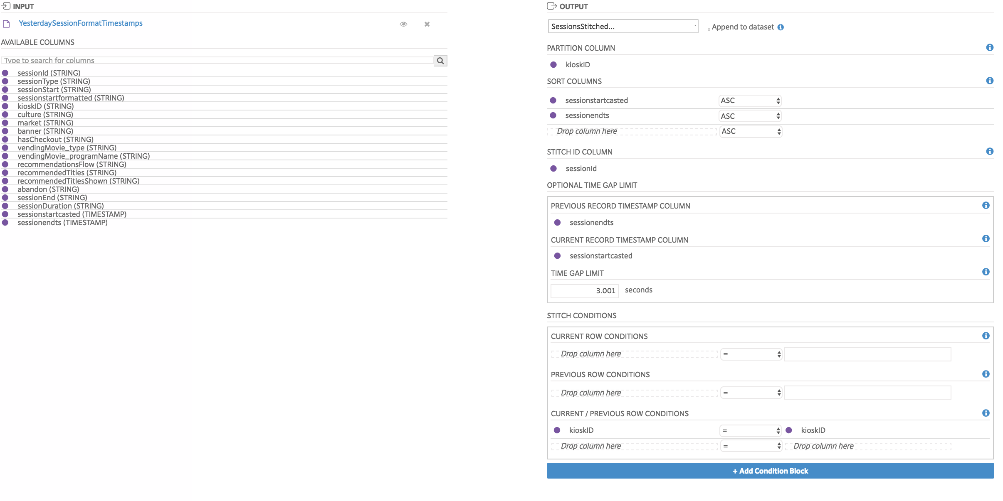

1. Join Stitch Sessions and Export

Pipe 1: Job 1

Job Type: Join and Filter

Input: Yesterday View Events Formatted Filtered

Input: SessionsStitchedFinal

Output: ViewEventsJoined

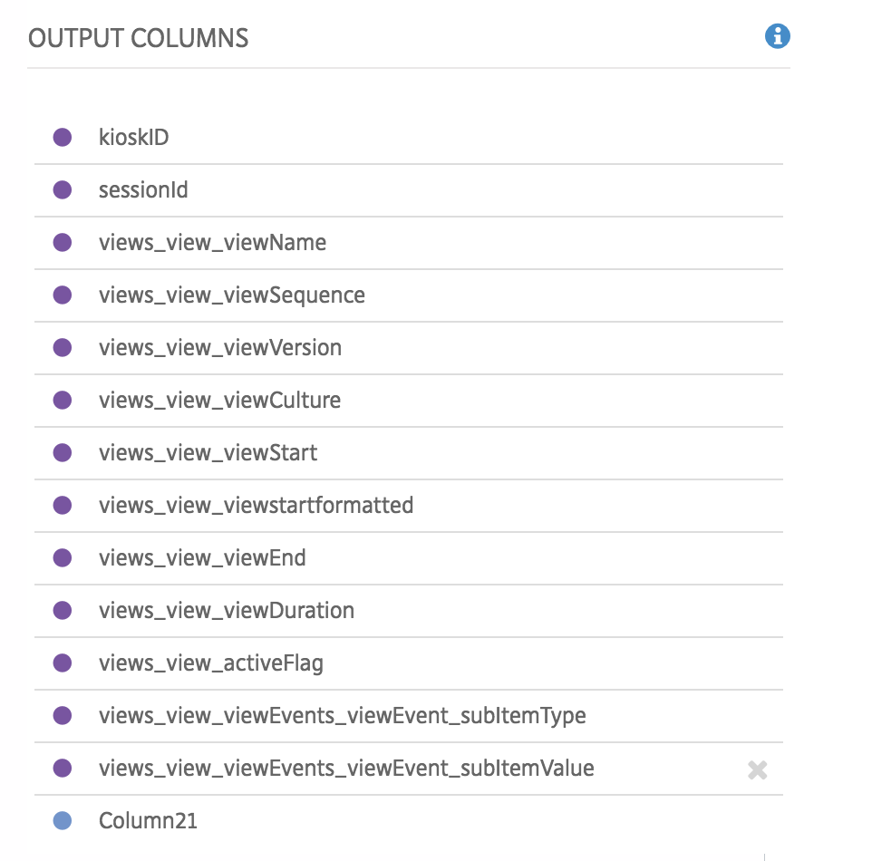

Joins:

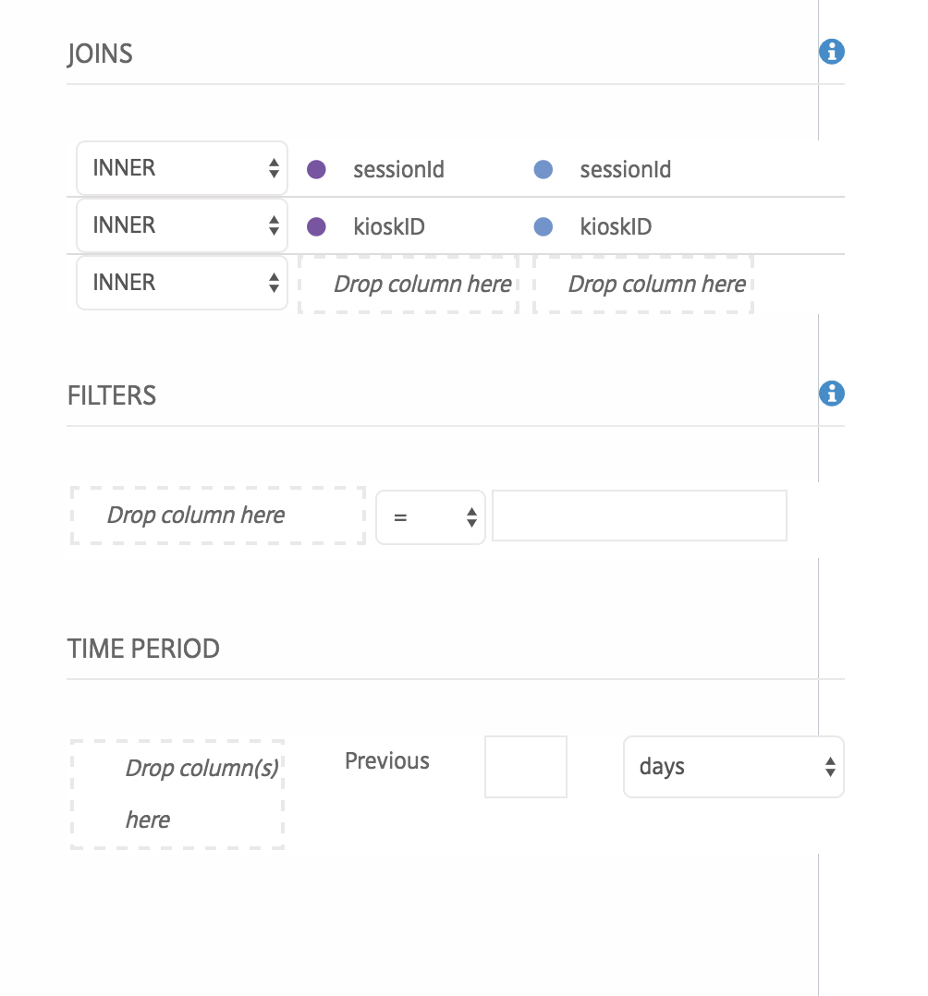

Pipe 1: Job 2

Job Type: Export to External Data Source

Input: ViewEventsJoined

Output: Adobe Redbox sFTP: /Prod/Amper/ViewEvents/@YYYY@-@MM@-@DD@_ViewEvents_Stitched

Compressed as zip

Pipe 2: Job 1

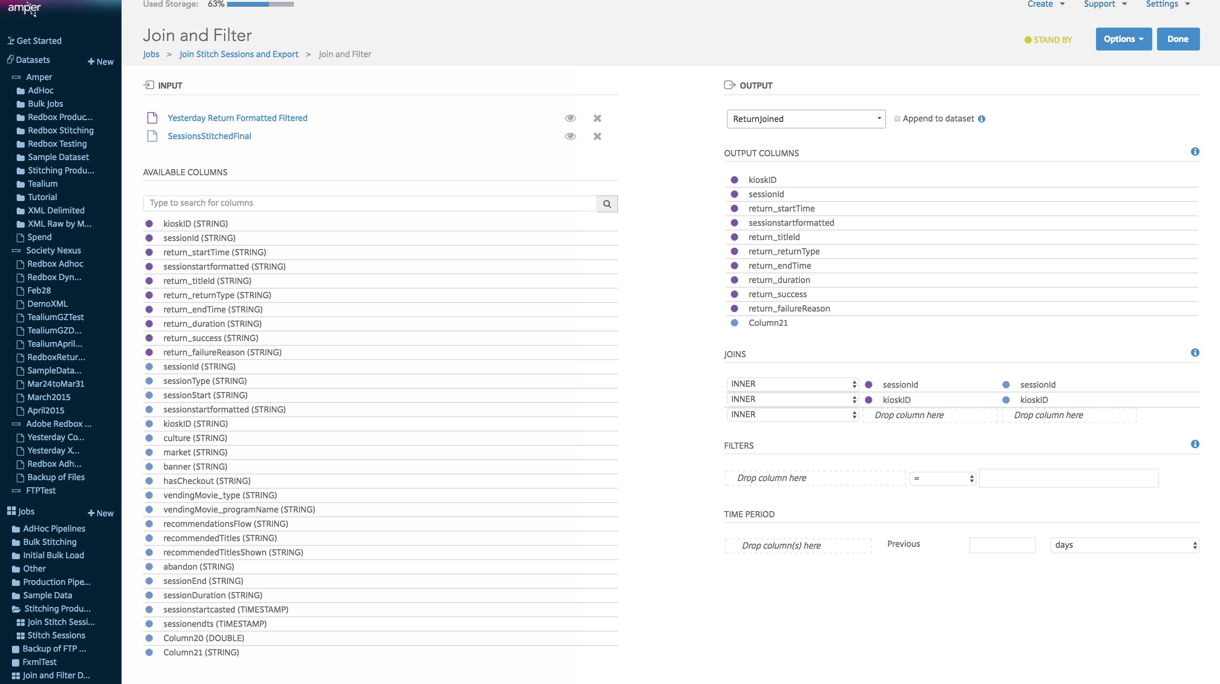

Pipe 2 Job 2

Output: Amper Redbox sFTP: /Prod/Amper/Returns/@YYYY@-@MM@-@DD@_Return_Stitched

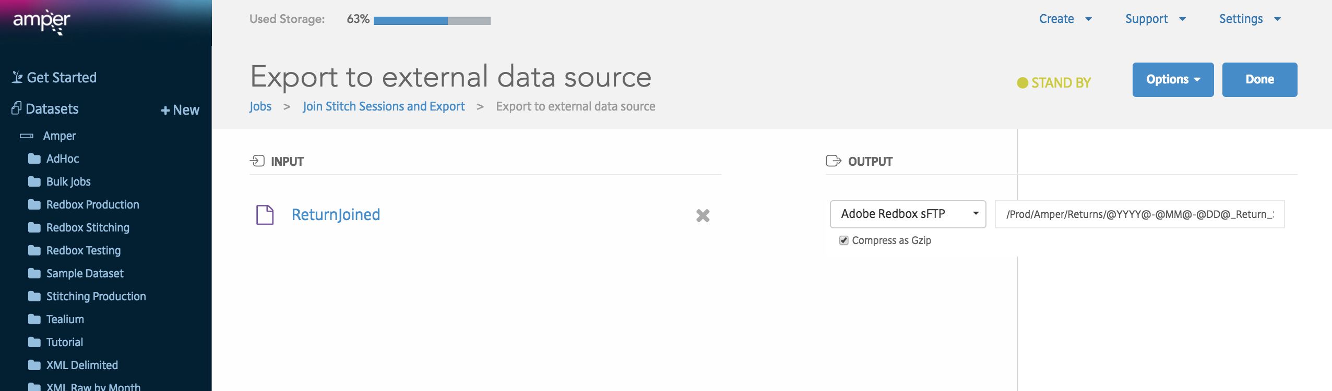

Pipe 3 Job 1

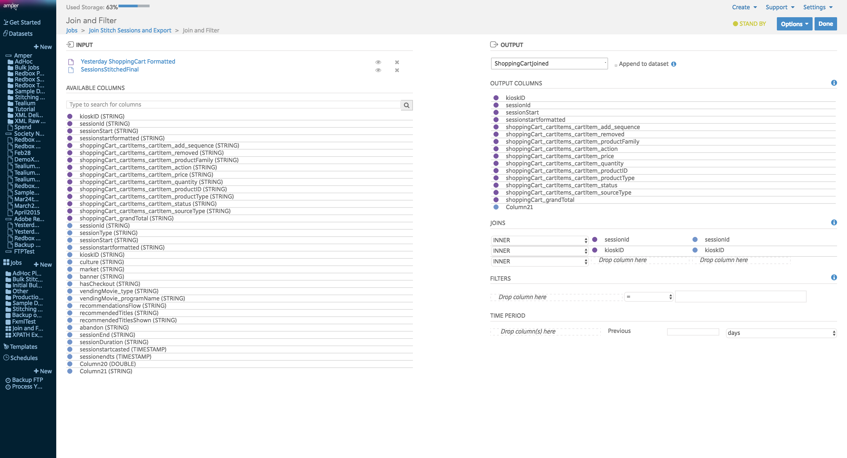

Pipe 3 Job 2

Output: /Prod/Amper/ShoppingCart/@YYYY@-@MM@-@DD@_ShoppingCart_Stitched

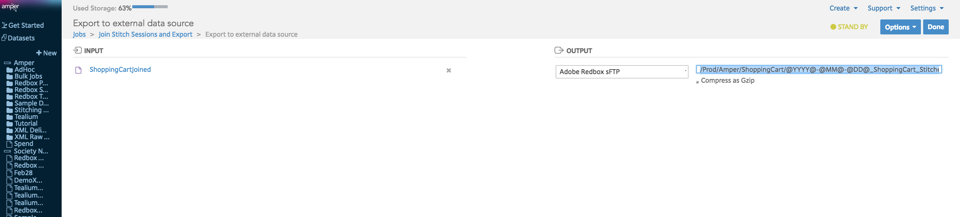

Pipe 4 Job 1

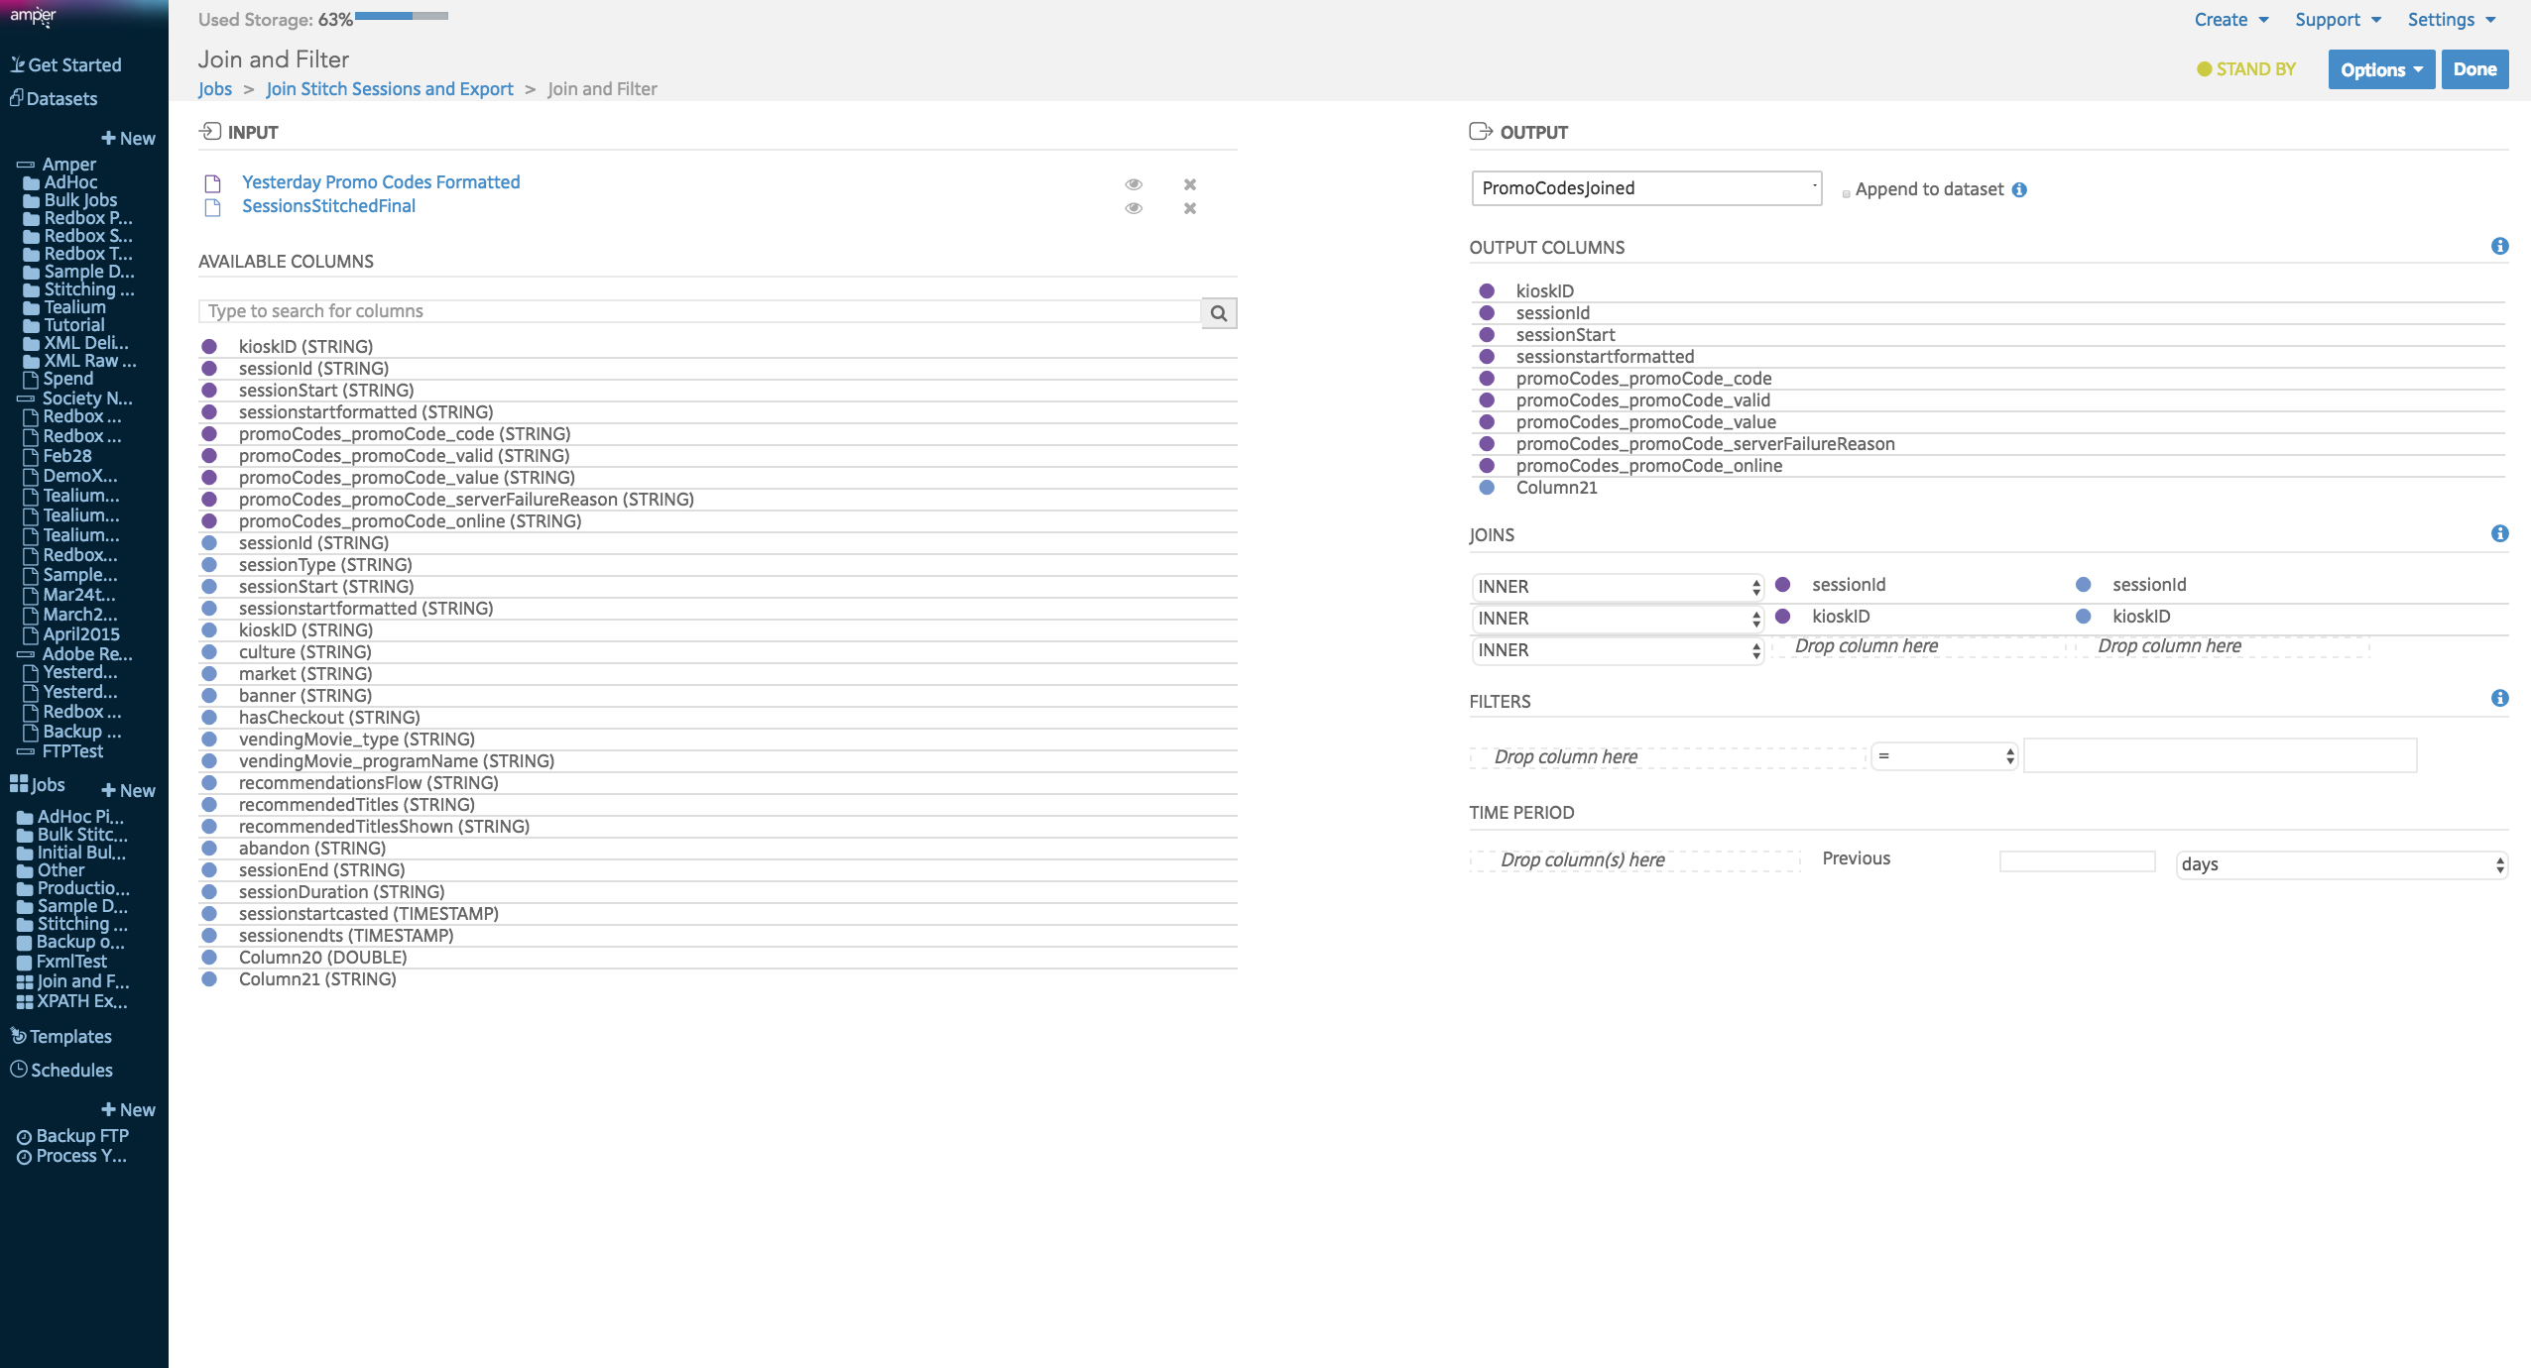

Pipe 5 Job 1

